HP ALM REQUIREMENT HISTORY

1. **Requirements details can be seen inside the history section and all the changes**

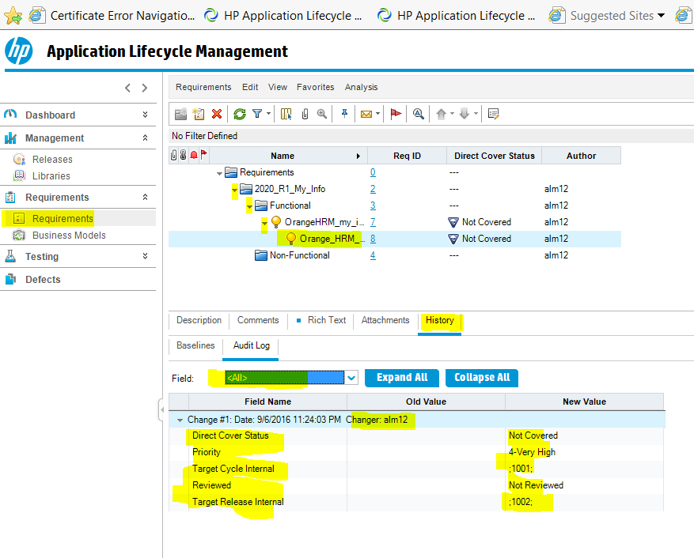

1. **If anyone makes a change about the requirement, we can see who changed it and when**

**As you can see in the history section there is a change 2 created and tells us alm12 change the direct cover status from not covered to not completed**

